Emergency Phone Tree Template

By Erin Sullivan
SearchDisasterRecovery

Emergency Phone Tree Template
When creating an emergency phone tree, three major components are required: contact information, call tree assignments and a standard message template. This information can be customized by the organization, and should be kept with the human resources department.
Contact information
When creating an emergency phone tree, human resources should have updated contact information for all members of the call tree. Ideally, more than one method of communication should be included, in the event that one is unreachable. These contact forms may be divided by team within the company and led by a manager or point person who will be contacted first. If someone is participating in the call tree, they should have access to this information concerning the people or person they are assigned to call. This format may vary by organization.
Team: ____________________
Manager: _________________

Employee | Job Title | Desk Phone | Mobile Phone | Home Phone | Email

Call tree assignments
To run efficiently, an emergency phone tree must have an established order of communication. Depending on the size of the organization in question and how many staff members need to be involved, each person should have a set number of people they should call to get the message across the company quickly. This template can provide a rough idea of a general call tree setup within one team:
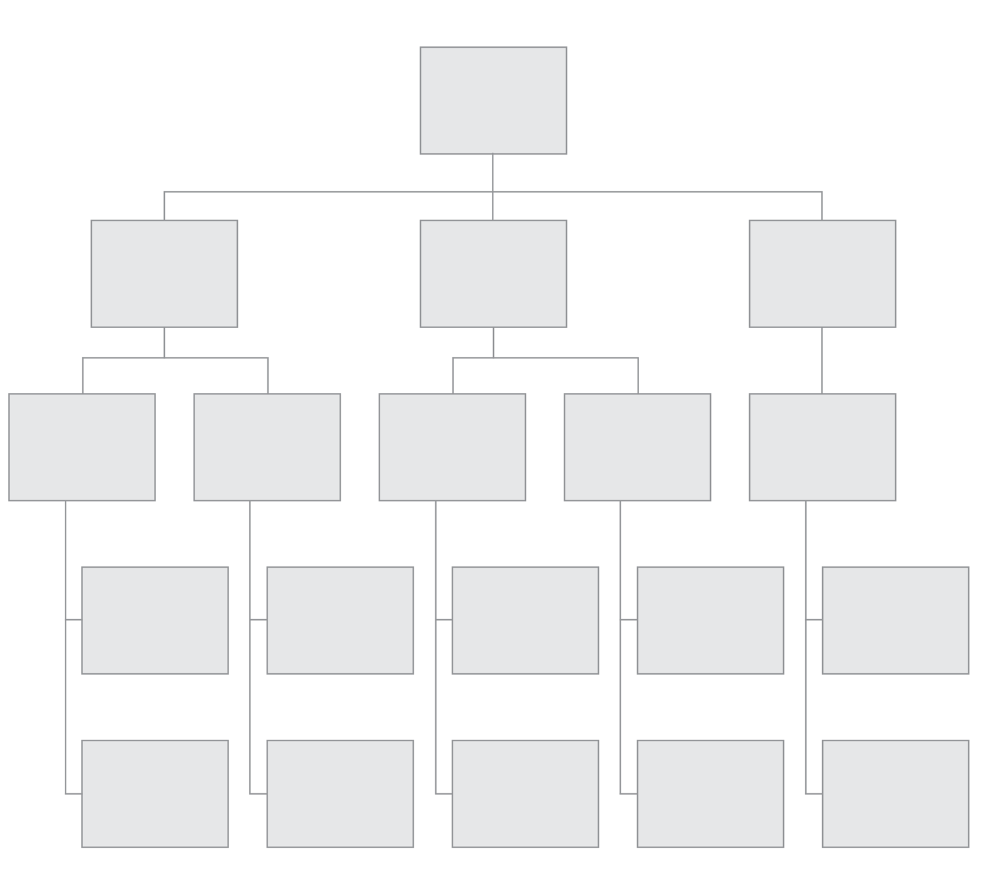

In the above scenario, the team manager receives the message, and then delivers it to the next four senior members of their team. Those four members then contact two other members, who, in turn, contact two members each. This format can be adapted based on the number of people in the organization and teams involved.

Standard message template
The message delivered in a phone tree should be concise enough to be delivered quickly, but also contain all of the important facts employees need to prepare for the situation and perform next steps. Updates may be made through a later call tree or other means of communication established in the primary message. Here is a general script for an emergency phone tree message:

Hello [Recipient], this is [Caller] with an emergency message from [Organization.] [Emergency incident] has occurred [name of location]. If you are [name of location], please follow these instructions [list of instructions for people on site.] If you are not [name of location], please do not return until the all-clear has been given. For more information, please dial the emergency hotline at [###-####-####.]

In the above situation, information is provided for those who are on-site and those who are at home. This may vary by organization and disaster, so adjust accordingly. Employees on company property may need to evacuate or stay put, depending on the situation, so be sure that the message reflects that. Include facts about the incident, as well as a way to get more information if it is available. At the end of the call, be sure to confirm that the recipient knows who they need to call next, and how to contact them.

