The Intention of this collection of screens and captions walk you through how I installed my OpenSolaris Storage Server. Images without captions are intended to be self explanatory.
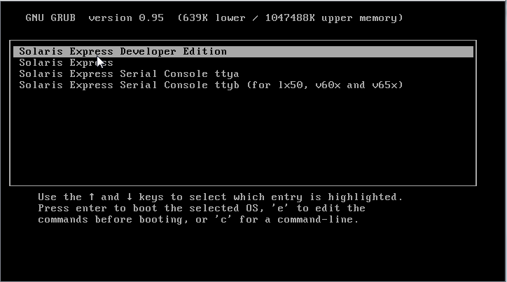
Figure 1. Initial Installation screen. Select "Developer Edition."
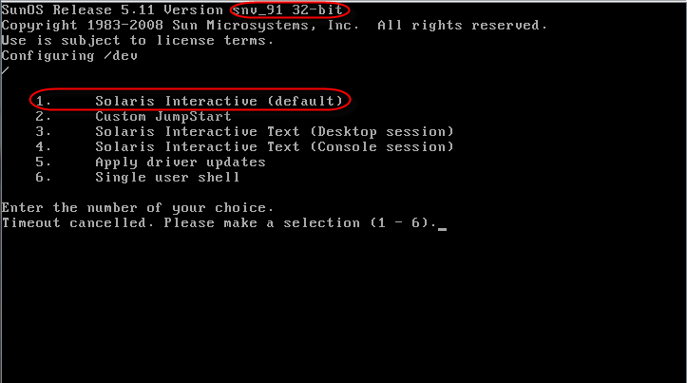
Figure 2. Select Interactive install. If you have problems with the interactive install, reboot and select Interactive Text (Console Session)
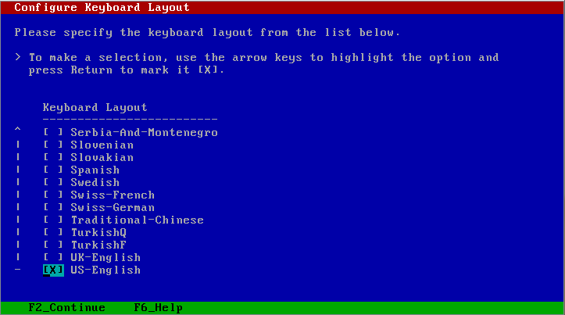
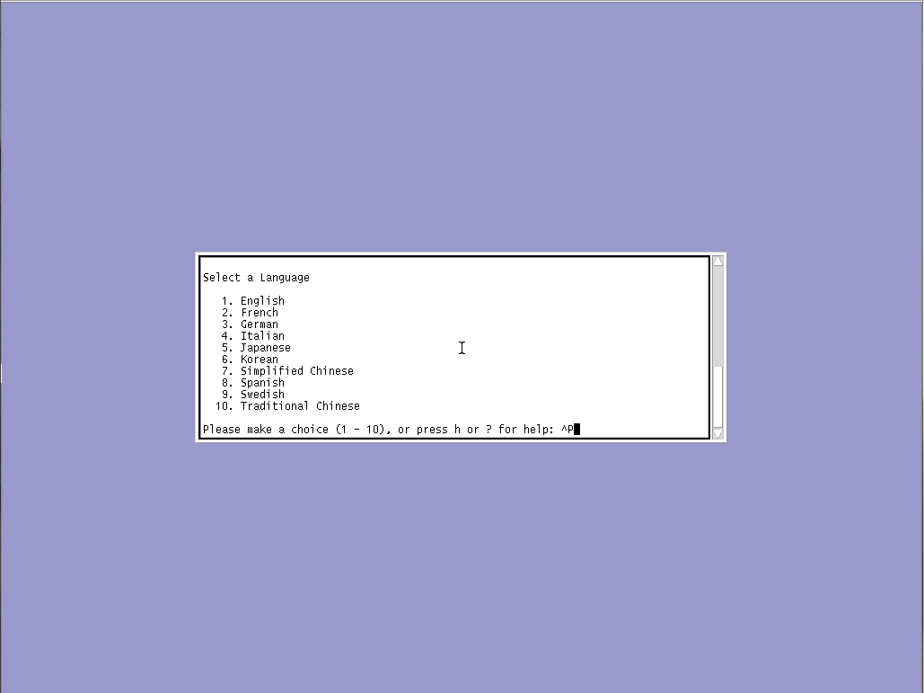
Figure 3. Select your language
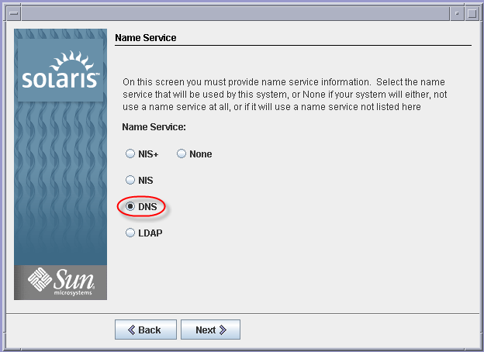
Figure 4. Don’t forget to choose DNS.

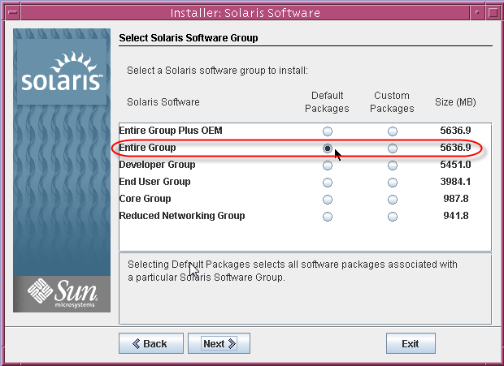
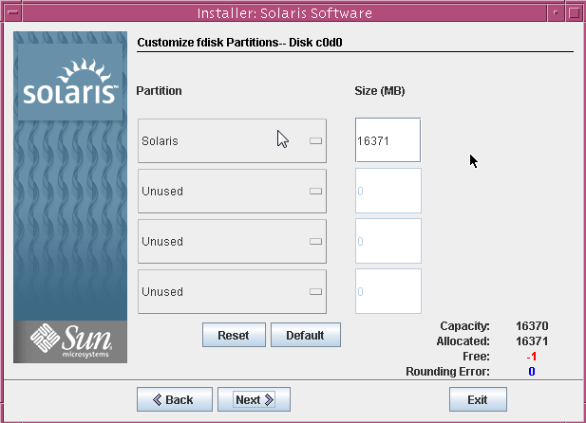
Figure 5. Choose your storage layout. I added more disk to this particular machine after I built it, however, if you have disks installed set them to the “Unused” state for now.
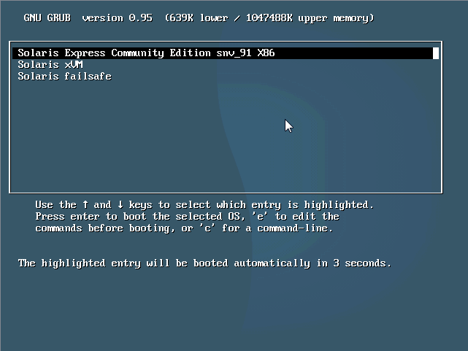
Figure 6. After about an hour and a reboot you have a pretty Grub screen! Don’t forget to remove the DVD.
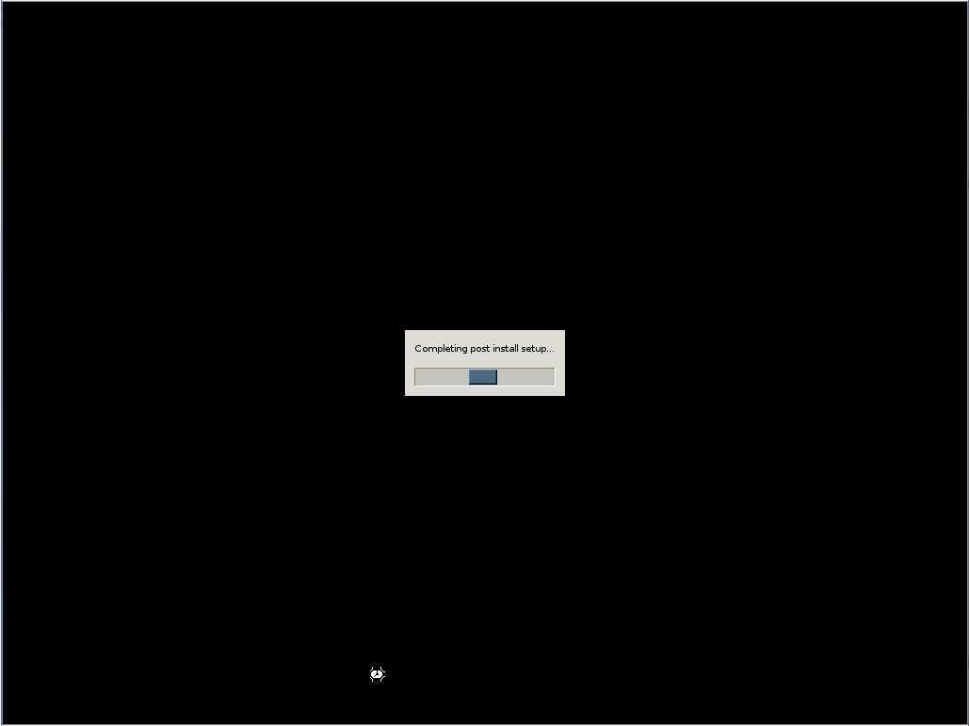
Figure 7 Not sure why, but I found this screen interesting.
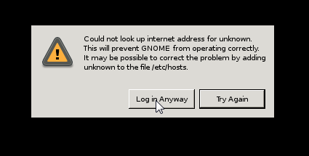
Figure 8. OpenSolaris is very picky about its hostname and DNS, click login anyway.
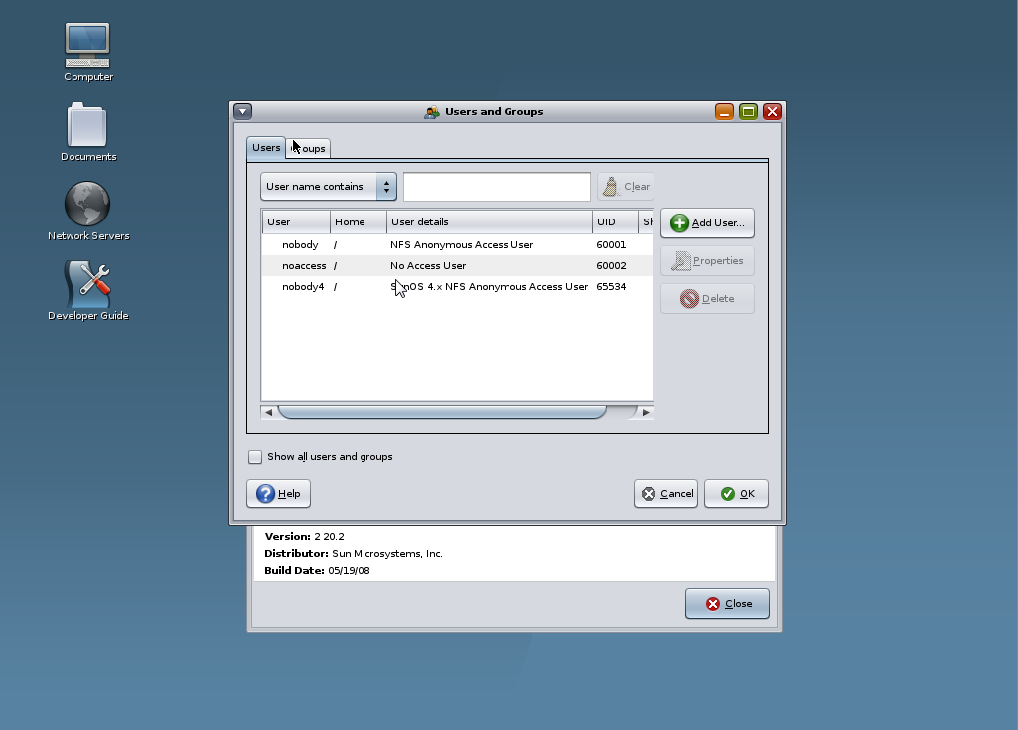
Figure 9. You are greeted with a "Create New User" applet. Do yourself a favor and create a new user.
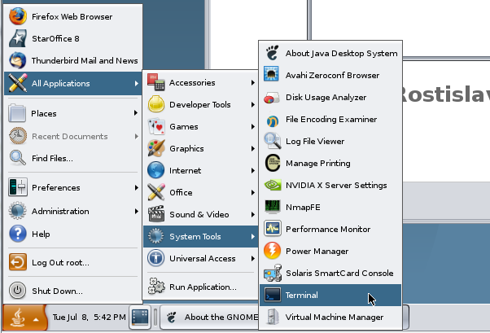
Figure 10. Fire up a terminal so we can install webmin.
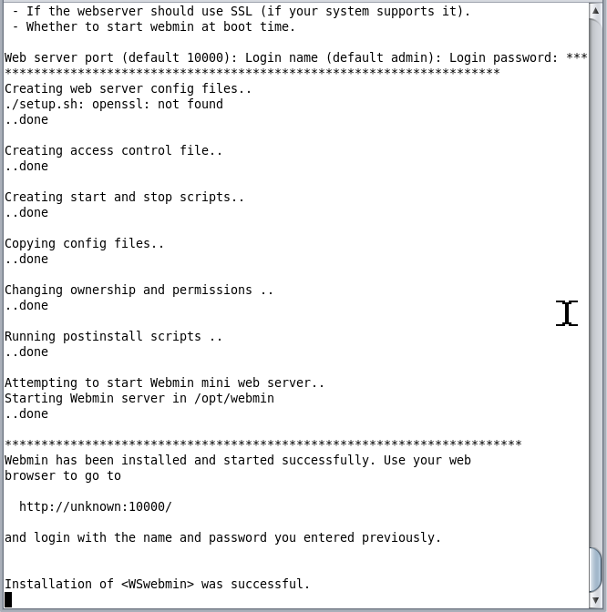
Figure 11. Run the commands below to download and install webmin. This assumes you have internet connectivity.
/Usr/sfw/bin/wget http://prdownloads.sourceforge.net/webadmin/webmin-1.420.pkg.gz
Gunzip webmin-1.420.pkg.gz
Pkgadd –d wemin-1.420.pkg

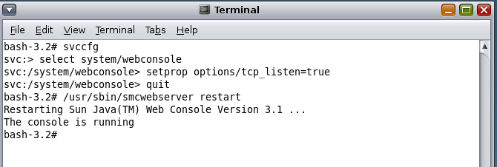
Figure 12. Configure the Java Web Console to allow access from the network.
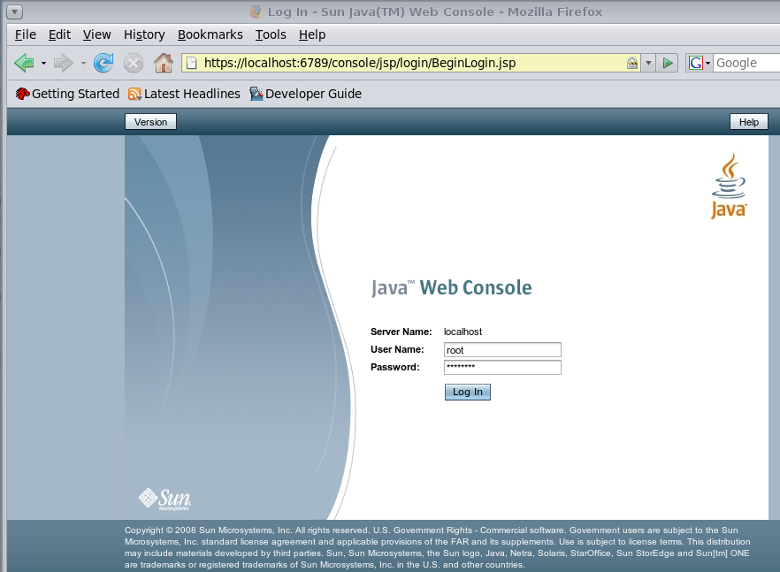
Figure 13. This is what it looks like but we aren't going to use this console in this how-to.
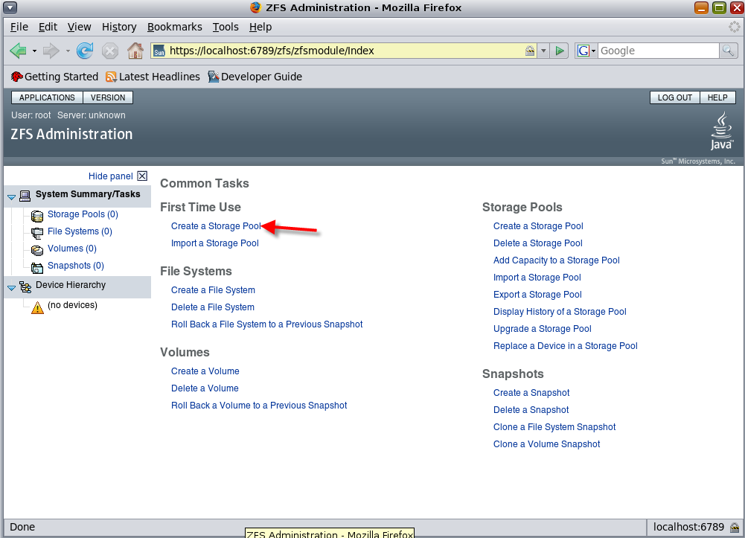
Figure 14. We are going to create a storage pool.
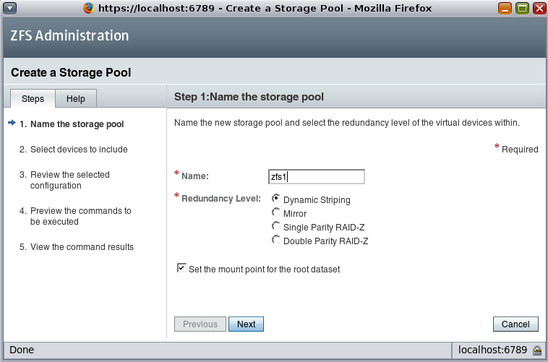
Figure 15. Name it something, below are the differences between the redundancy levels:
I used dynamic striping. You can find out more about the different redundancy levels here:
http://www.solarisinternals.com/wiki/index.php/ZFS_Best_Practices_Guide#Should_I_Configure_a_RAID-Z.2C_RAID-Z2.2C_or_a_Mirrored_Storage_Pool.3F
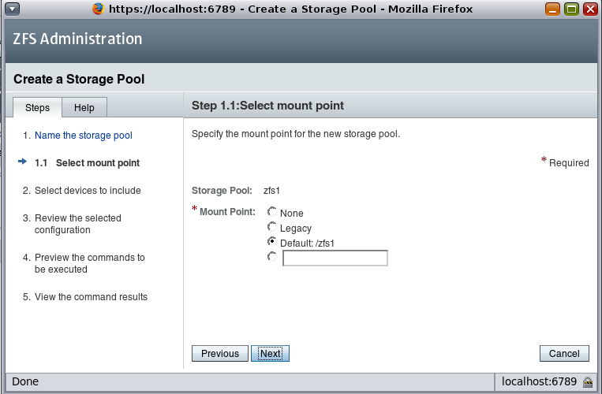
Figure 16. I selected the suggested mount point for my pool.
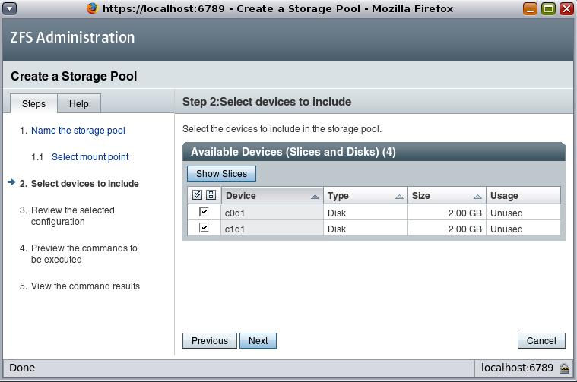
Figure 17. I used two disks in my pool; you will have to check off the disks you plan to use. Be sure you didn't format your disks as part of the install process.
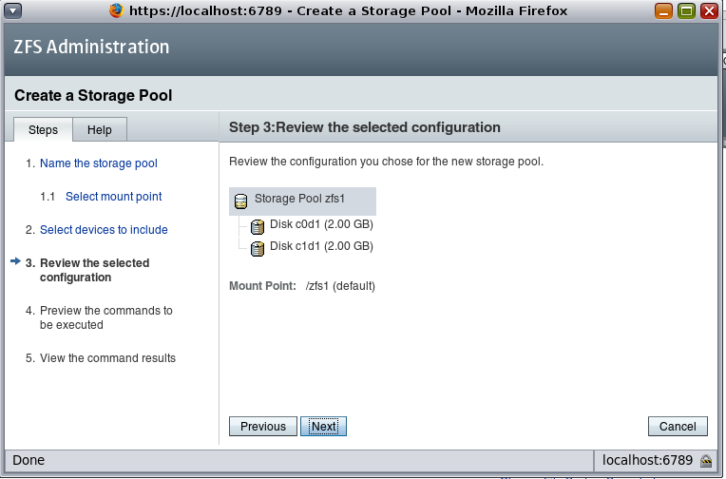
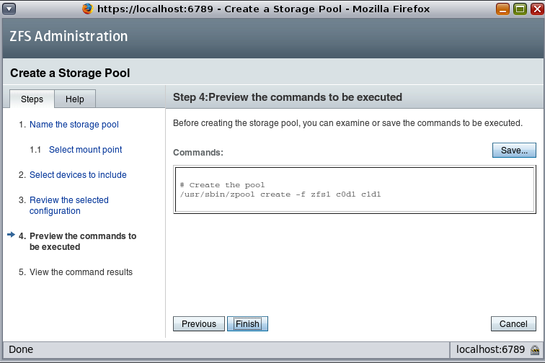
Figure 18. This is my favorite part of this tool. It exposes all the commands you need to enter on the command line to do these things yourself, making it a learning as well as an administrative tool.
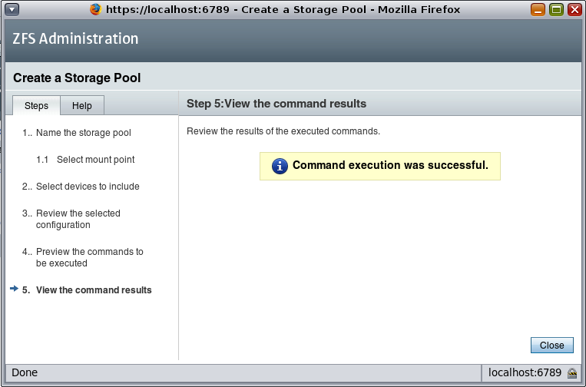
Figure 19. Once your pool is created (and if you are using b91) you will encounter a small bug in the Java Web Console that is easily fixed.

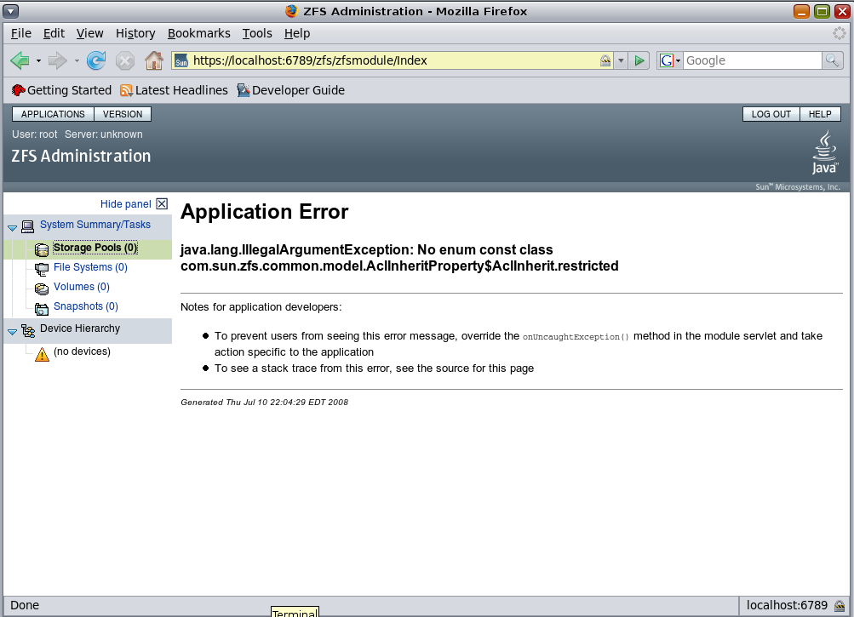
Figure 20. This is the bug, and the commands to fix it are below.
From a terminal enter: zfs set aclinherit=passthrough <storage pool name>
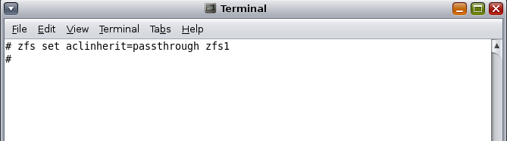
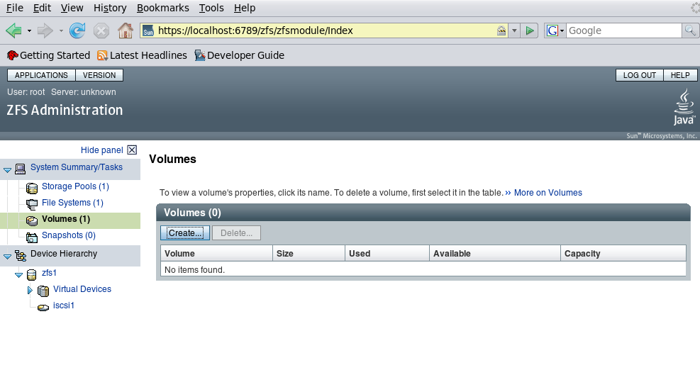
Figure 21. Fixes you right up! I created and deleted some volumes before I refreshed when I took this screen so things are a little out of synch.

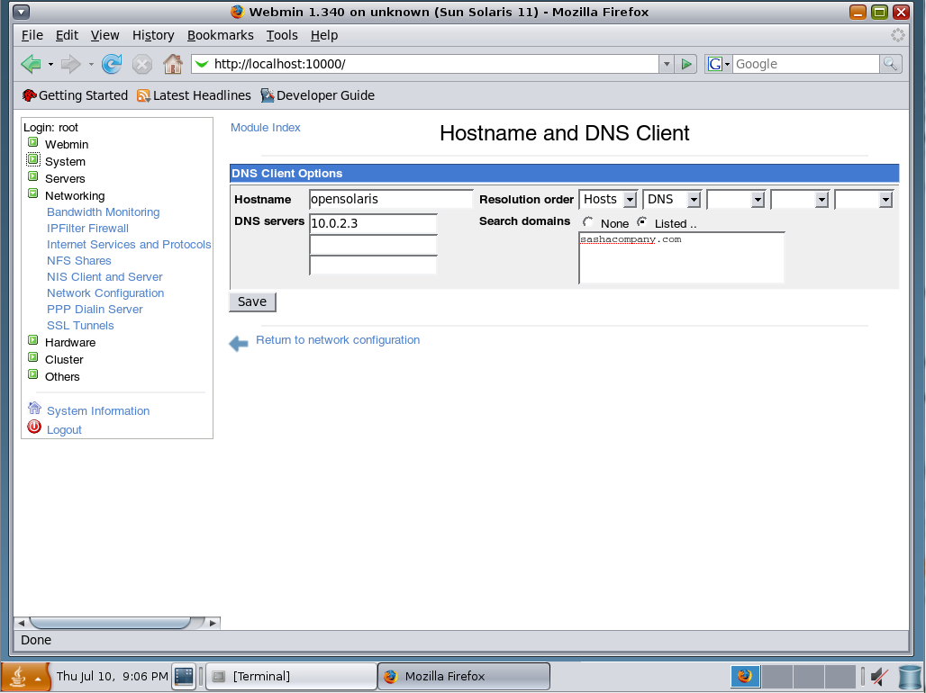
Figure 22. Connect to webmin and select Networking, and then network configuration edit your hostname.

Open a terminal again:
Figure 23. We are going to turn you into a command line jockey here.
Enter these commands to create and publish via iSCSI a 150 Megabyte volume (adjust the size to suite your needs):
zfs create -V 150M zfs1/iscsi-vol2
zfs set shareiscsi=on zfs1/iscsi-vol2
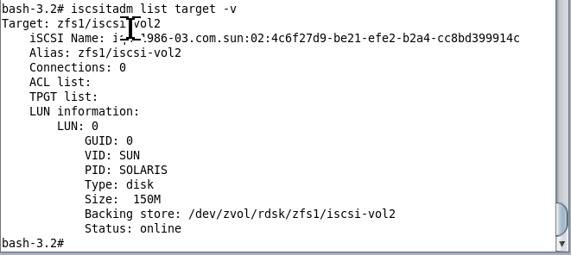
Figure 24. You should end up with something that looks like this (type iscsitadm list target –v) in a command prompt to view this information.
Now you need to create a target port group, enter the following command in a terminal:
iscsitadm create tpgt 1
The number one is what I called my target port group
Now we need to add an ip address to my target port group, but first we need to figure out what our IP address is:
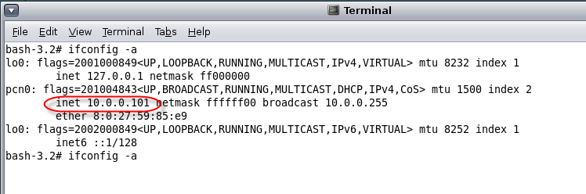
Add this ip to your target port group with this command:
iscsitadm modify tpgt -i 10.0.0.101 1
Remembering that 1 is the name of my target port group
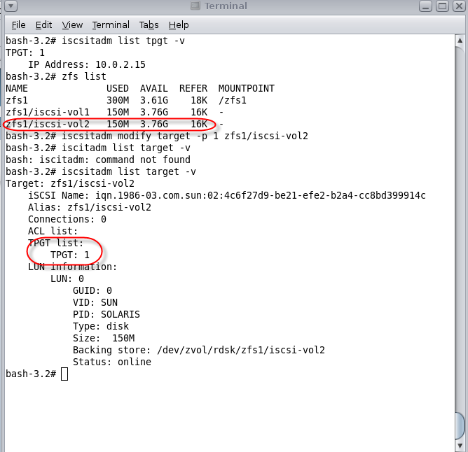
Figure 25 Shows me adding the volume to the port group, I didn't photoshop my typo :).
These are the commands:
iscsitadm modify target –p 1 zfs/iscsi-vol2
When you view your target you should see what port group it is a member of:
iscsitadm list target –v
We are DONE, you have shared out a volume via iSCSI. Now let’s attach to it.
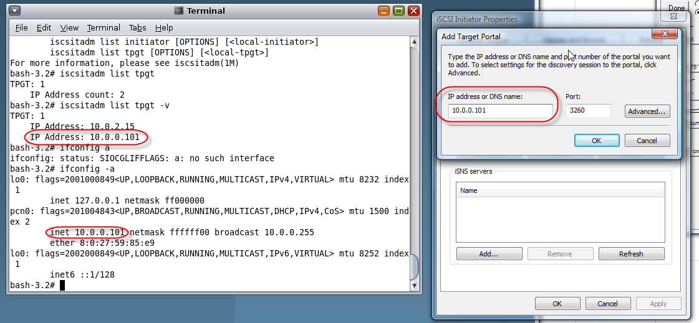
Figure 26. Vista's iSCSI initiator tool, type in the IP address in your portgroup into the portal box.
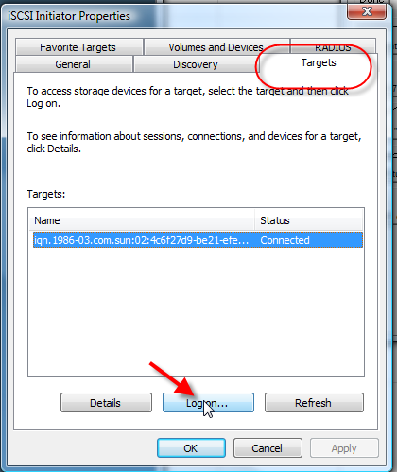
Figure 27. Go to the Targets tab and click the logon button.
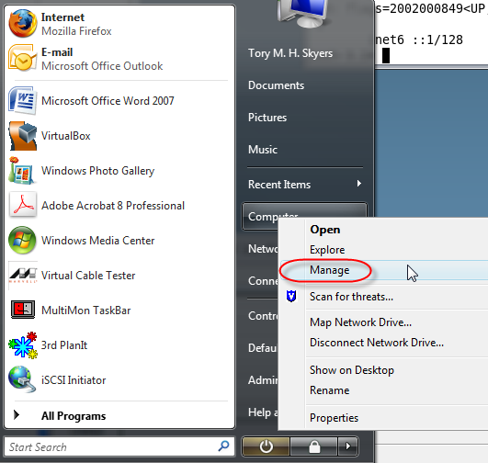
Figure 28. Right click on manage from your start orb.
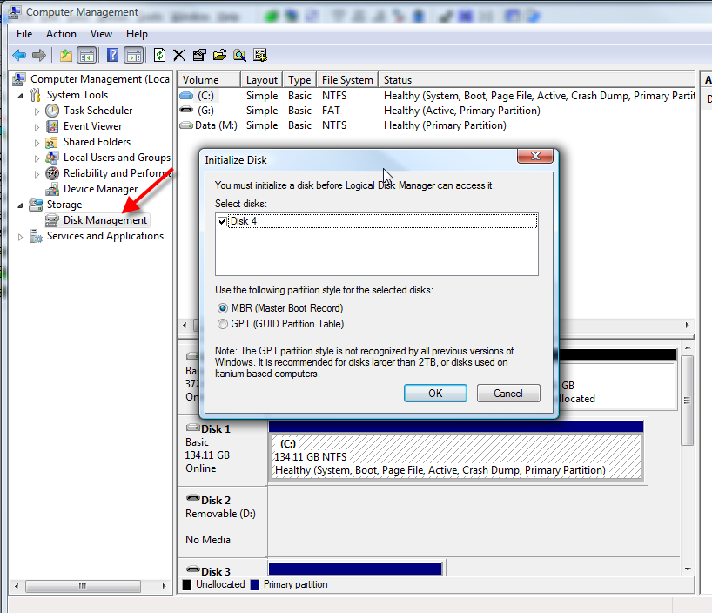
Figure 29. Once you open the Disk Management snap-in you will be prompted to initialize your new iSCSI disk!
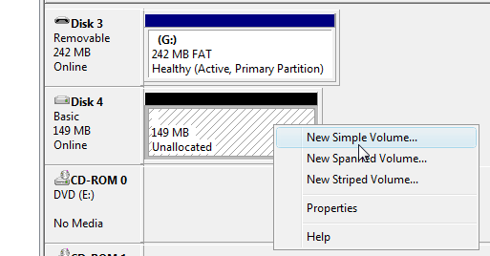
Figure 30. Create a volume, format it and you are done!!
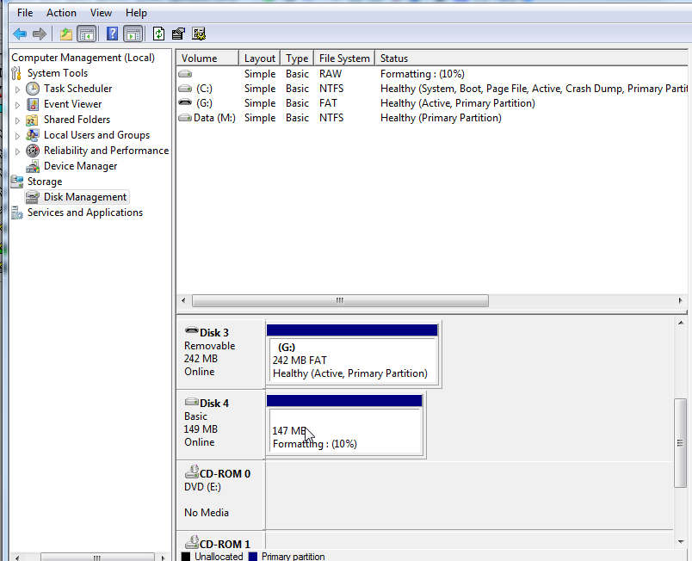

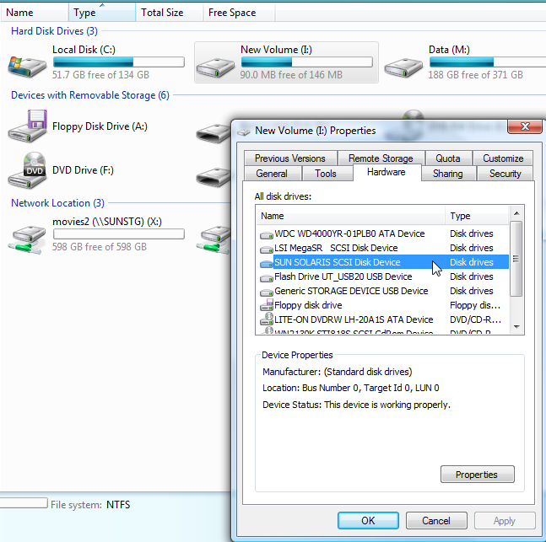
Figure 31. I copied some files to my drive to test it.
This is going to seem like a cheat compared to all the stuff you had to do for iSCSI. I’ve included a list of commands, but I’m going to cheat and suggest you read this site for a step by step on how to add CIFS to the iSCSI mix:
http://blogs.sun.com/timthomas/entry/configuring_the_opensolaris_cifs_server
The prerequisite here is that you’ve created a volume for CIFS.
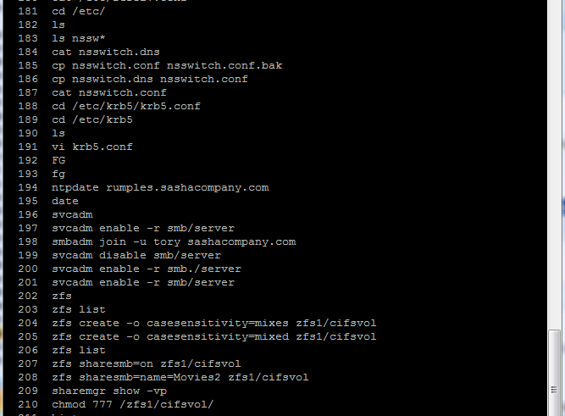
I cannot take credit for all these commands. I’ve simply collected them from various places on the Internet and documented the steps. Below is a table of links to all the sources I used.
How to enable external access
http://opensolaris.org/os/community/ha-clusters/ohac/Documentation/SCXdocs/relnotes/
Fix zfs bug
http://opensolaris.org/jive/thread.jspa?threadID=61906&tstart=0&start=0
Create iSCSI Target
http://scottf.wordpress.com/2008/03/12/solaris-iscsi-target-with-esx-302-server/

